SMART HOME SECURITY SYSTEM
A report submitted by-
1. MANASHJYOTI DAS (190610003050)
2. ARINDAM HAZARIKA (190612603008)
3. MANISH KAKATI (190610003051)
4. SAMUDRA DAIMARY (190610003075)
5. VINAYAK NATH (190610003089)

Under the guidance of
Prof - DR. BARNALI GOSWAMI
Professor Department of Electrical Engineering



Department of Electrical Engineering
ASSAM ENGINEERING COLLEGE, JALUKBARI

ACKNOWLEDGEMENT

With sincere gratitude, we express our earnest thanks to Dr. Barnali Goswami for her constant involvement, energetic efforts, and proficient guidance throughout the progress of the project. Without her wise counsel and encouragement, it would have been impossible for us to complete this project work in proper time and form. Their guidance and counsel kept us motivated throughout the entire duration of our project work.
Finally, we would also love to thank our fellow friends, from other microprocessor and microcontroller groups with whom we had numerous discussions on the domain, and with whom we faced numerous challenges together in learning, and understanding the working of microcontrollers and microprocessors

CANDIDATE’S DECLARATION

We hereby declare that the work which is being presented in this report entitled “SMART HOME SECURITY SYSTEM”, in partial fulfilment for the degree of Bachelors of Technology of Electrical Engineering in Assam Engineering College, under Assam Science Technology University is an authentic record of our own work carried out under the supervision of Dr. Barnali Goswami, Department of Electrical Engineering, Assam Engineering College, Guwahati, Assam. The matter presented in this report has not been partially or fully copied.

Manashjyoti Das 190610003050
Arindam Hazarika 190612603008
Manish Kakati 190610003051
Samudra Daimary 190610003075
Vinayak Nath 190610003089

B.Tech (Electrical Engineering), 8 th Sem
Assam Engineering College, Guwahati,
Assam.

FORWARDING CERTIFICATE

This is to certify that Manasjyoti Das (190610003050), Arindam Hazarika (190612603008), Manish Kakati (190610003051), Vinayak Nath (190610003089), Samudra Daimary (190610003075 has/have carried out the project work “Smart home security system” under the supervision of Dr Barnali Goswami and has/have compiled this thesis reflecting the candidate’s work in the semester long project. The candidate(s) did this project full time during the whole semester and the analysis, results, claims etc. are all related to his/her/their studies/study and works during the semester.
I/We recommend submission of this thesis as the partial fulfilment of the requirement for the degree of Bachelor of Technology in Electrical Engineering of Assam Science and Technology University.

Prof. Aroop Bardalai

(HOD)
Department of Electrical Engineering
Assam Engineering College
Jalukbari, Guwahati – 781013

CERTIFICATE FROM THE SUPERVISOR

This is to certify that Manashjyoti Das (190610003050), Arindam Hazarika (190612603008), Manish Kakati (190610003051), Vinayak Nath (190610003089), Samudra Daimary (190610003074) has/have carried out the project work “Smart Home Security System” under my supervision and has/have compiled this thesis reflecting the candidate’s work in the final year project. The candidate(s) did this project full time during the whole semester and the analysis, results, claims etc. are all related to his/her/their studies/study and works during the semester.
I recommend submission of this thesis as the partial fulfilment of the requirement for the degree of Bachelor of Technology in Electrical Engineering of Assam Science and Technology University.

Dr Barnali Goswami
(Professor)

Signature:
Department of
Electrical Engineering
Assam Engineering College, Jalukbari
Guwahati - 781013

ABSTRACT

In this work, the design and implementation of a microcontroller-based home security system with GSM technology have been presented and analysed. One microcontroller with other peripheral devices which include Radar Sensor, PIR sensor, LDR sensor, Buzzer, and Global System for Mobile Communication (GSM) Module is responsible for the reliable operation of the proposed security system. In addition, a mobile phone is interfaced with a microcontroller through Wi-Fi connectivity to control the system. At last, the results of the practical circuit show the proper functions and also verify the reliable security within a reasonable cost.
This security system based on ESP32 camera module detects any kind of suspicious activity inside the place. As such the sensors fitted along with it detects the activity thereby activating signals which are sent towards the microcontroller which again activates an alarming signal along with switching on and off the light so that the user becomes aware of the activity inside the room. Also, with the creation of some third-party applications we can also get the pictures of the suspicious activity.

LIST OF FIGURES

Title Page no.

Fig 3.1.1 – Pin out Diagram of ESP32 CAM 20

Fig 3.1.2 – Circuit diagram 22
Fig 2.2.1 - ESP 32 camera module 11
Fig 2.2.2 - 1CH Relay Module 12
Fig 2.2.3 - RCWL Radar Sensor 12
Fig 2.2.4 - PIR sensor 13
Fig 2.2.5 - LDR Sensor 14
Fig 2.2.6 - TTL module 15
Fig 2.2.7 - Buzzer 16
Fig 2.2.8 - Bread Board 16
Fig 2.2.9 - AC Bulb 17
Fig 2.2.10 - Servo motor 18
Fig 2.2.11 - 5v DC adapter 19
Fig 3.3.1 - Notification from the bot to smartphone 24
Fig 3.3.2 - Clicking photograph manually using command 24
Fig 3.4.1 - Commands for manual control 26
Fig 5.1 Working model 30

Table of Contents
Acknowledgment
List Of Figures

Contents Page Number
Chapter 1. Introduction 8-10
  - Preamble 8-9
  - Aim 9-10
Chapter 2. Components used 11-19
Chapter 3. Proposed Methodology 20-25
3.1 Hardware Description 20-21
3.2 Circuit Diagram 22
3.3 Working 23-24
3.4 Interfacing with telegram 25-26
Chapter 4. Software Used 27-28
4.1 Arduino IDE 27-28
4.2 TTL module 28
Chapter 5. Result and Observation 29-30
Chapter 6. Applications 31
Chapter 7. Conclusion and future scopes 32-33

- INTRODUCTION

1.1 Preamble
Throughout the history of mankind, the importance of security has always been a great matter of concern. Home automation refers to a domestic environment that improves the quality of the resident's life by facilitating a flexible, comfortable, healthy, and safe environment. With the rapid development of computers and networks, Internet-based home security has advanced a lot in residential areas. Home automation is a process for improving the quality of resident's life by facilitating a flexible, comfortable, and secure environment. The home security system is the most prominent feature of home automation. Traditional techniques of alarm-based security have gained much popularity in past decades. An integrated security system is a centralized platform combining various security parameters such as a wireless alarm system, access control devices, and video surveillance. Being integrated can allow the information to be expedited and facilitate a better response across all systems. For high-quality home automation, the selection of sensors is very important. A control system is good if the sensors used to measure the desired variables can transmit the measured values.
Automatic anti-theft techniques are important applications used in almost all modern gadgets and smart homes. The system for integrated security monitoring automatically is achieved by using ESP32 camera module based microcontroller system. ESP32 due to its increased popularity finds its varied range of applications. Motion detecting sensor PIR, the light-detecting LDR sensor, a buzzer, and ESP32 camera module with the use of some relay is the hardware used to interface with the computer, and then any kind of suspicious activity is detected in the room.
The microcontroller-based home security system has become so important that it acts as a benchmark for testing and simulation of particular sensors for detection and monitoring of various situations happening around the house. Various types of projects like minor projects as well as major projects are carried out on suitable hardware and software platforms.

ESP32 camera module takes the help of some third party applications available in the telegram software known as ‘ BOTS ‘. These bots can control the camera module as well as all the sensors and also ensuring rotation of the camera for proper coverage of the area.
1.2 Aim:
The primary focus of our work is to install wireless smart home security system to protect our assets and people inside it. The main aim and objectives behind designing of this project are as follows:
Intrusion Detection: The PIR sensor detects human presence by sensing infrared radiation emitted by their bodies. The objective is to trigger alerts and notifications whenever motion is detected in the monitored area. This helps detect potential intrusions or unauthorized access.
Light-Based Security: The objective is to use the LDR sensor to detect sudden changes in light, such as when someone tries to tamper with or disable the lighting in the monitored area. Alerts or notifications can be triggered in response to such events.
Object Detection and Tracking: The radar sensor is used to identify harmful threats, and trigger an alarm.
Visual Monitoring: The use of camera module is to visually monitor the area under surveillance. The objective is to automate actions based on sensor inputs.
The prime objective of this work is to allow the user to monitor and control the Home Security System from anywhere with an internet connectivity.

- COMPONENTS USED

Different electronic elements had been used in order to obtain the desired results in the present work. The components include different types of sensors, relays, microcontroller, wires for connection, electrical components, breadboard where all the components have been connected. Most of the components used in the project run on low volt dc supply (3-5v), but a couple of them use 230 v ac. Below there is the detailed description of each of the components used in the project.

  - ESP 32 Camera

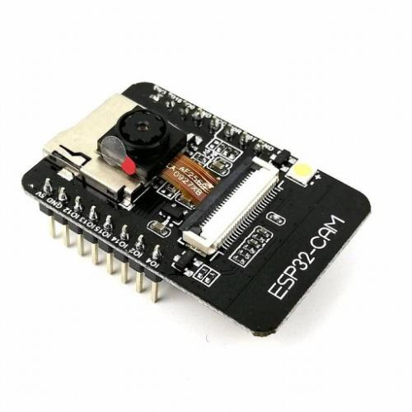
Fig 2.2.1 - ESP 32 camera module
Fig 2.2.1 shows an ESP 32 camera module. Using the ESP 32 camera module, the need for a microcontroller was eliminated and hence the cost of making was reduced. The ESP32-CAM provides an inexpensive way to build more advanced home automation projects that feature video, taking photos, and face recognition. The ESP32-CAM is a full-featured microcontroller that also has an integrated video camera and micro-SD card socket. It’s inexpensive and easy to use, and is perfect for IoT devices requiring a camera with advanced functions like image tracking and recognition.
  - 1CH RELAY MODULE
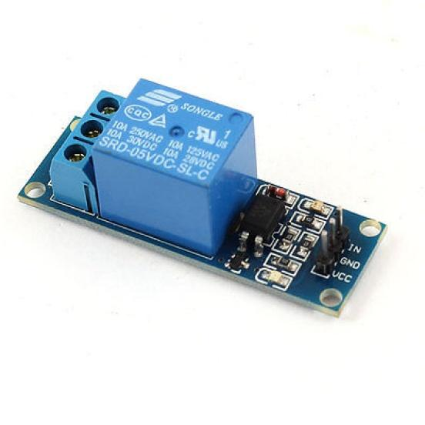
Fig 2.2.2 - 1CH Relay Module
Fig 2.2.2 shows a 1CH Relay Module. The Single Channel Relay Module is a convenient board that can be used to control high voltage, and a high current load such as motor, solenoid valves, lamps, and AC load. It is designed to interface with a microcontroller such as Arduino, PIC, etc.

  - Radar Sensor
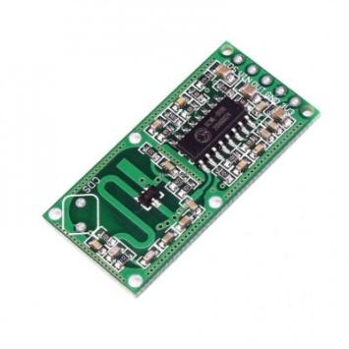
Fig 2.2.3 - RCWL Radar Sensor
Radar sensors are conversion devices that transform microwave echo signals into electrical signals. They use wireless sensing technology to detect motion by figuring out the object's position, shape, motion characteristics, and motion trajectory. One of the biggest advantages radar sensors have over other sensors is their detection of motion and velocity.

  - PIR sensor
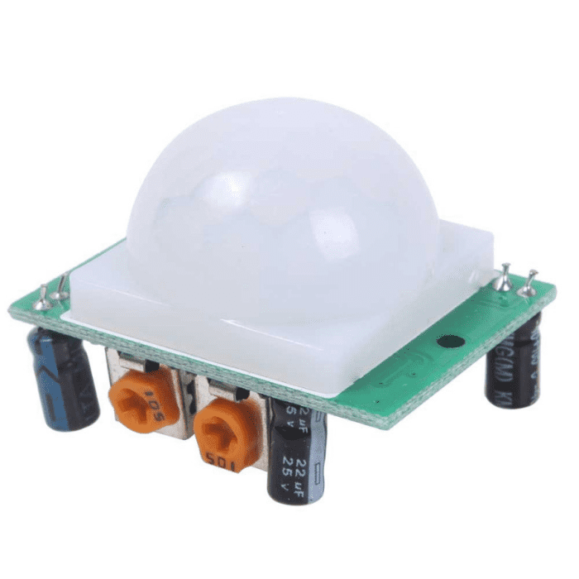
Fig 2.2.4 - PIR sensor
Fig 2.2.4 shows a PIR sensor. PIR sensors is useful to sense motion, almost always used to detect whether a human has moved in or out of the sensor range. They are small, inexpensive, low-power, easy to use, and don't wear out. They are often referred to as PIR, "Passive Infrared", "Pyroelectric", or "IR motion" sensors. PIRs are made of a pyroelectric sensor that can detect levels of infrared radiation. Everything emits some low-level radiation, and the hotter something is, the more radiation is emitted.

  - LDR Sensor
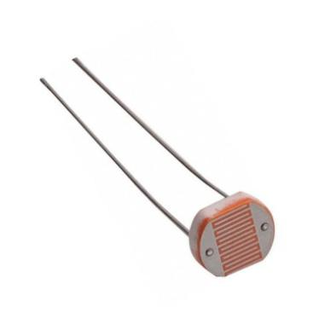
Fig 2.2.5 - LDR Sensor
Fig 2.2.5 shows a LDR Sensor. Photo resistors are light-sensitive resistors whose resistance decreases as the intensity of light they are exposed to increases. Photo resistors, also known as light-dependent resistors (LDR), are light-sensitive devices most often used to indicate the presence or absence of light or to measure light intensity. In the dark, their resistance is very high, sometimes up to 1 MΩ, but when the LDR sensor is exposed to light, the resistance drops dramatically, even down to a few ohms, depending on the light intensity. LDRs have a sensitivity that varies with the wavelength of the light applied and are nonlinear devices.

  - TTL module
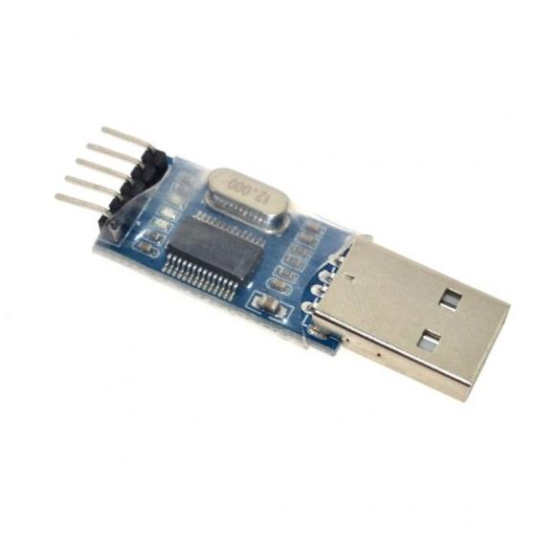
Fig 2.2.6 - TTL module
Fig 2.2.6 shows a TTL module. TTL stands for transistor-transistor logic. TTL module is a great little tool for embedded systems that require a serial connection to a computer. The board can simply attach to a USB bus and will appear as a standard COM port. The TTL converter module is a signal conditioning module which converts an analog signal into a TTL pulse. It is typically used to convert the signal from a blade passage into a TTL pulse. TTL or Transistor-Transistor Logic is a standard method of making logical circuits using transistors. Digital logic circuits are the main basic part of any electronic devices such as computer, laptops, smartphones, etc. A computer CPU has many complex logical circuits inside it. So many transistors are connected to each other in the TTL method to make the logical circuits.

  - Buzzer
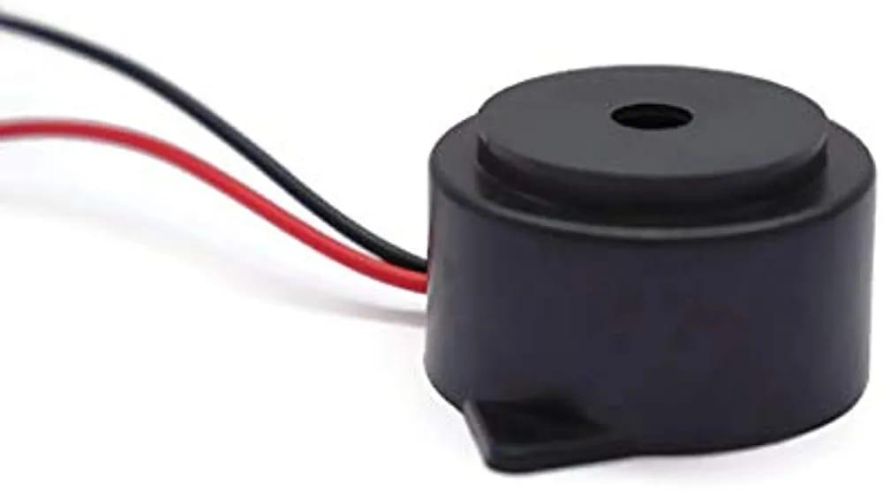
Fig 2.2.7 - Buzzer

Fig 2.2.7 shows a Buzzer. A buzzer or beeper is an audio signalling device, which may be mechanical or electromechanical. Typical uses of buzzers and beepers include alarm devices, timers, and confirmation of user input such as a mouse click or keystroke. In this project the buzzer has been connected to the esp camera module. Based on the data received from the sensors, it will give an output of the object detected to the LCD and buzzer. The LCD will show an alert message and the buzzer will make an alarming sound for a few seconds which will confirm to the host that there is someone or a moving object in that area.

2.8 Bread Board
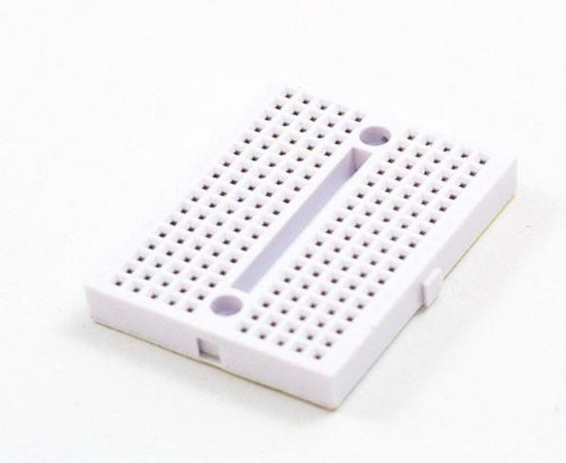
Fig4.2.8 - Bread Board
Fig4.2.8 shows a Bread Board. A breadboard, solderless breadboard, or protoboard is a construction base used to build semi-permanent prototypes of electronic circuits. Unlike a perboard or stripboard, breadboards do not require soldering or destruction of tracks and are hence reusable. For this reason, breadboards are also popular with students and in technological education.
  - AC light bulb

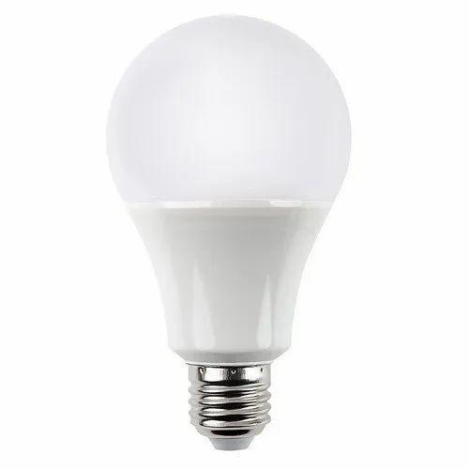
Fig 2.2.9 - AC Bulb

Fig 2.2.9 shows an AC Bulb. The change in direction of the current flow happens so fast that the light bulb does not have a chance to stop glowing. The light bulb does not care if it is using DC or AC current.

  - Servo Motor

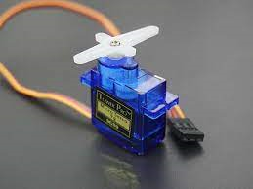
Fig 2.2.10 - Servo motor

Fig 2.2.10 shows a Servo motor. A servo motor is a type of motor that can rotate with great precision. Normally this type of motor consists of a control circuit that provides feedback on the current position of the motor shaft, this feedback allows the servo motors to rotate with great precision. If you want to rotate an object at some specific angles or distance, then you use a servo motor. It is just made up of a simple motor which runs through a servo mechanism. If motor is powered by a DC power supply then it is called DC servo motor, and if it is AC-powered motor then it is called AC servo motor.

  - 5v DC supply
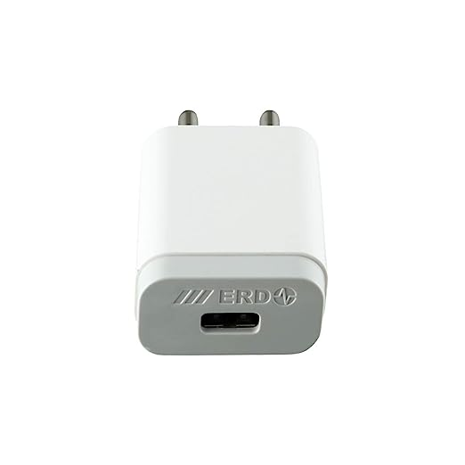
Fig 2.2.11 – 5v DC adapter

5V power supplies (or 5VDC power supplies) are one of the most common power supplies in use today. In general, a 5VDC output is obtained from a 50VAC or 240VAC input using a combination of transformers, diodes and transistors. 5V power supplies can be of two types: 5V regulated power supplies, and 5V unregulated power supplies.5V regulated power supplies come in three styles: Switching regulated AC to DC, Linear regulated AC to DC, and Switching regulated DC to DC.

- Proposed Methodology
The system works mainly based on two approaches, wired communication and wireless communication. The wireless communication is carried out through wifi-internet connection.

The controller that is used in this project is an ESP32 CAM. The ESP32-CAM is a small size, low power consumption camera module based on ESP32. It comes with an OV2640 camera and provides onboard TF card slot. The Wi-Fi connectivity is also done through this board.
3.1 Hardware Description

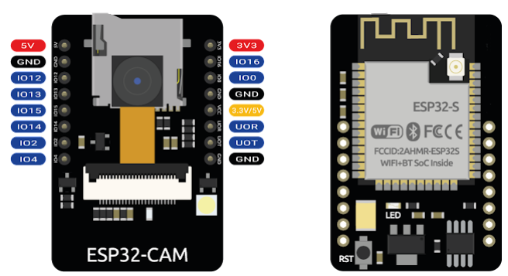
Fig 3.1.1 Pinout Diagram of ESP32 CAM

Fig 3.1.1 shows the pinout diagram of ESP32 CAM. The pins are used for input and output as follows:

5V - to 5v supply
GND - to Ground
IO12 - to Radar Digital output
IO13 to - to PIR out
IO15 - to LDR out
IO14 and IO2 - to 2ch Relay
IO4 - to Buzzer
IO16 - to Servo in

3.2 Circuit Diagram
The ESP32-CAM is a full-featured microcontroller that also has an integrated video camera and microSD card socket. It’s inexpensive and easy to use, and is perfect for IoT devices requiring a camera with advanced functions like image tracking and recognition. The figure 3.1.2 shows the pinout of the ESP32 CAM.

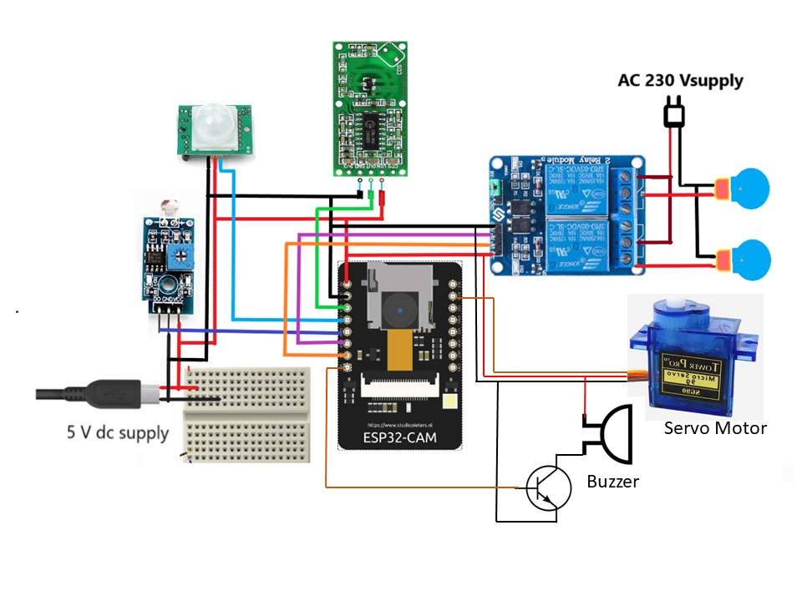
Fig 3.1.2 – Circuit diagram

3.3 Working of the circuit
The components such as the PIR Sensor, RCWL Radar Sensor, LDR sensor, 2 Channel relays, Buzzer, AC light bulb, Servo Motor, all are connected as shown in the circuit diagram. Though the circuit shown is a simplified one, actually it is very congested to do the wirings on a bread board. For this reason, a PCB (Printed Circuit Board) was made for reducing wiring mess and using less space. Now according to the PCB design, the components were connected and soldiered together.

The system does 3 types of detection- direct motion in front of the sensor, motion beyond a solid object, and light intensity.
Motion sensing is done by the PIR sensor and the RADAR sensor. Now if the PIR/Radar sensor is placed on places where possible threats may pass by, it will detect and send a signal to the controller. The LDR sensor is given to add an automatic light activation during night hours. The AC light bulb is controlled through a relay where the LDR sends an input when the resistance value goes beyond a threshold value. All this Input signal from the sensors are then processed by the microcontroller and then the output is provided. The output of the controller for the PIR and RADAR is a buzzing sound from the buzzer included, and a notification is sent to the smartphone along with a photograph of the scene at that moment. Figure 3.3.1 shows the notification type
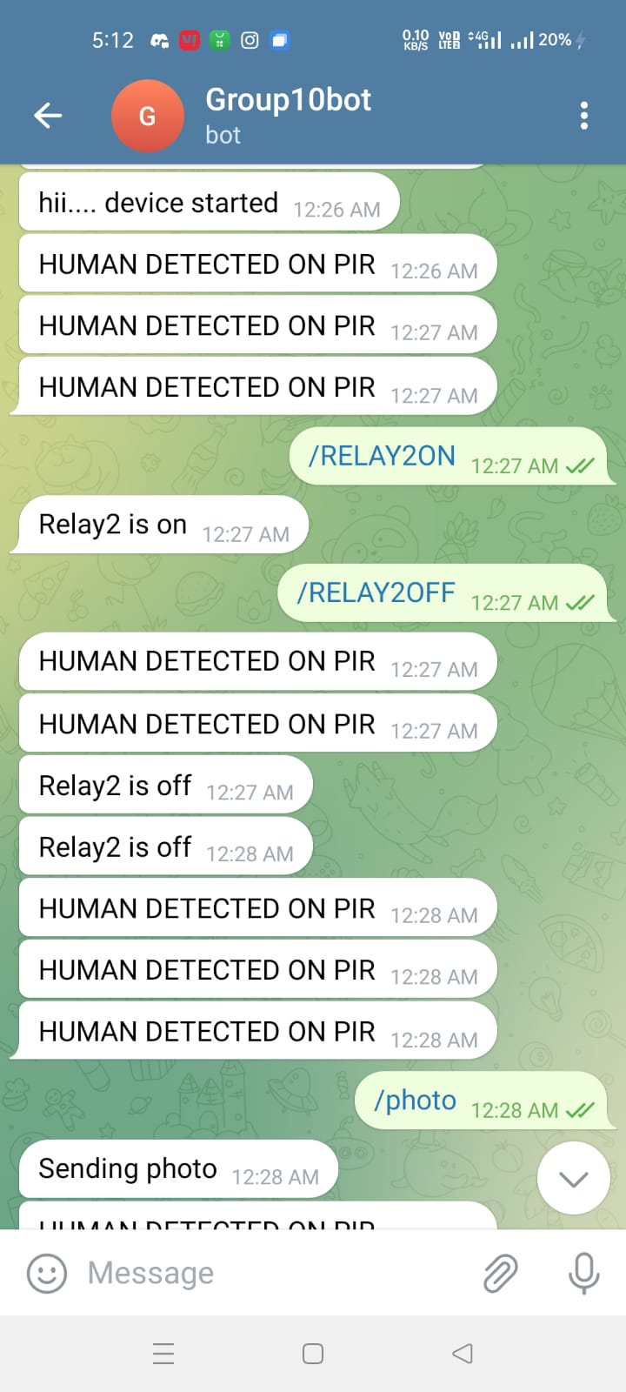
Fig 3.3.1 : Notification from the bot to smartphone

The photo can also be manually clicked with the help of commands in the telegram app. The command for clicking photo is “/photo”. Figure 3.3.2 shows receiving manual photograph in the app.
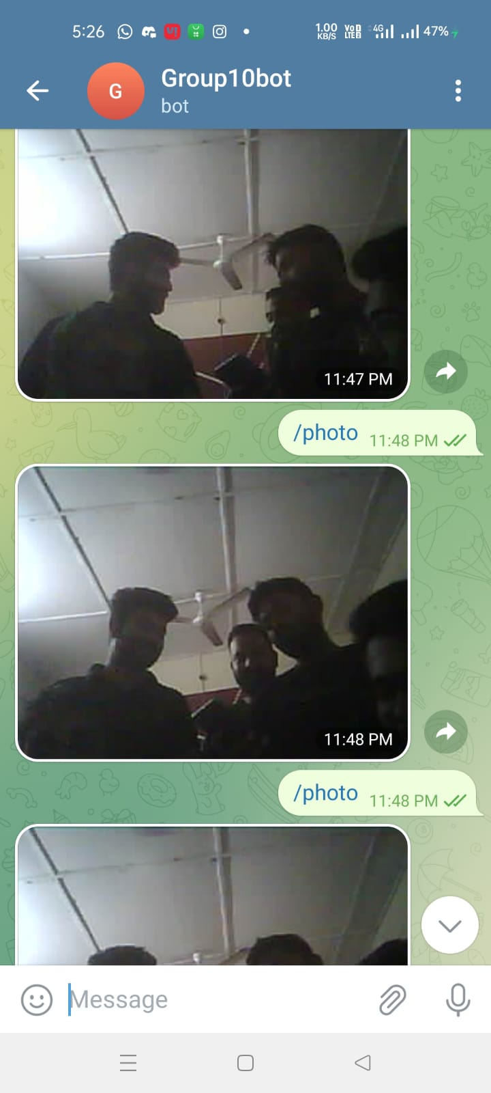

Fig 3.3.2 Clicking photograph manually using command

3.4 Interfacing with telegram

Smartphone connectivity is the key point of the system, which is achieved by the app called Telegram. Telegram has feature by which we can create AI bots.
The process of creating bots is:
On the telegram app, there is a search bar where @Botfather is typed and started a chat with it. Then a command “/newbot” is sent and a new unique bot is created. The bot is given a name and a unique username for identification. After creation of the bot, a unique chat ID and a token number is generated which is required for communication of the ESP with that unique bot. The chat ID and the token number is provided during coding for giving the address of communication.

Internet is required for online communication of remote control of the system which is achieved by the inbuilt wifi module in the controller. For this there must be a wifi connection in the area where the system is to be installed. The wifi ID and password is provided to the controller through coding and then when the system is run, it automatically scans for the wifi ID and password and connects with it.
The connection established is known by the flashing of the led, when switched on, the flash starts glowing and when it detects wifi and connects the flash is turned of automatically and a message goes to the user that the device has started.
Now the signal from the motion sensors give two outputs- the buzzer goes off and the camera module takes a picture at that instant. Then the photo is sent to the user which has the unique chat ID. Multiple chat IDs can be stored so that different users can control the device if required.
The sensors can be controlled through the BOT, such as turning ON/OFF a particular sensor, Rotation of the servo, clicking pictures manually, turning ON/OFF all the sensors etc.
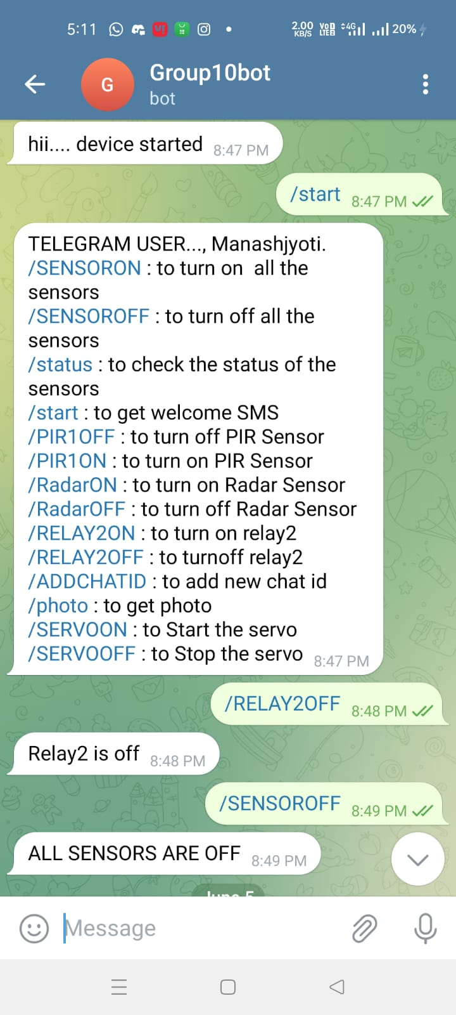
Fig 3.4.1 Commands for manual control
Fig 3.4.1 shows the various commands and their functions. This command menu is displayed when the command “/start” is given to the bot.
Here /ADDCHATID is used to add different chat ids provided in the code. This enables multiple users to control the system.

- Software used

The software used for programming the Arduino Uno in this project is Arduino IDE1. The Arduino Integrated Development Environment - or Arduino Software (IDE) - contains a text editor for writing code, a message area, a text console, a toolbar with buttons for common functions, and a series of menus. It connects to the Arduino hardware to upload programs and communicate with them. Programs written using Arduino Software (IDE) are called sketches. These sketches are written in the text editor and are saved with the file extension .ino. The editor has features for cutting/pasting and searching/replacing text. The message area gives feedback while saving and exporting and also displays errors. The console displays text output by the Arduino Software (IDE), including complete error messages and other information. The bottom right-hand corner of the window displays the configured board and serial port. The toolbar buttons allow you to verify and upload programs, create, open, and save sketches, and open the serial monitor.

4.1 Arduino IDE
Arduino is not the only IDE that helps to compile code for ESP32 and flash it into the microcontroller. There is ESP−IDF which is the official development framework for ESP32, which provides much more flexibility in terms of configuration options. However, it is hardly as intuitive and user−friendly as the Arduino IDE. Also, with the number of supporting libraries built for ESP32 in Arduino, courtesy of the huge developer community, there's hardly any functionality of ESP32 which can't be realized with the Arduino IDE.
Now, to install the ESP32 board in the Arduino IDE, the following steps needs to be followed −
- It is made sure that the Arduino IDE is present.
- File −> Preferences
- In the Additional Boards Manager URL, the following is entered
- https://dl.espressif.com/dl/package_esp32_index.json

ESP32 board has been installed, installation can be verified by going to Tools −> Boards. A whole bunch of boards is seen under the ESP32 Arduino section. The board of choice is chosen i.e. ESP32 CAM.

4.2 TTL module
The ESP 32 PPIO0 pin has two modes: 1. Boot mode 2. Run Mode.
When the PPIO0 pin is grounded, it acts as a pin for programming the ESP cam. And it is ungrounded, it has an inbuilt high which enables the ESP cam to run the uploaded program. The use of TTL module is to enable the PPIO0 pin to work as the pin used for data transfer during programming thus enabling to fetch the code to the controller.

- Results and observation

The Systems connects itself automatically to the Wi-Fi whose details are provided in the code, the connection established is made sure by a flashing led in the ESP cam. When the flashing stops it means the system is connected to the Wi-Fi. It usually connects in around 2-5 seconds.
Whenever the PIR sensor senses the motion of any suspicion inside the room, it observed that message “ Human detected on PIR “ , is displayed on the user’s phone. An alarming sound from the buzzer give the assurance of any suspicious activity happening around the room. During night time, it is observed that the ac mains light bulb glows up upon getting the signal from the LDR sensor via ESP32. The servo motor rotates the camera module in order to get better view of the area. The camera clicks a photograph of the object and sends it to the user. The photograph is received on telegram app.
Manual control of the sensors , relays, camera and servo is possible through the bot by providing specified commands. Multiple chat ids can be associated with system if provided in the code

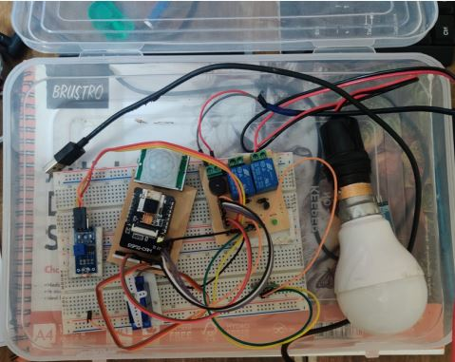
Fig 5.1 Working model

- Applications
This security system can be used for various purposes:
- This system can be used as an alarming device for protection. This can be used in homes as well as different facilities like shops, personal workplace etc.
- It has the purpose of home automation by using the LDR sensor as a switching device for lightbulbs which turns on automatically during night and turns off during the day.
- It can be used to monitor the area from different location. This feature is useful when the user is not near by or working in some other place.

- Conclusion and future work

'Smart Home Security System' detects motion and sends an alarm through a buzzer. PIR motion sensors along with a Radar sensor have been used to detect an object beyond a solid surface, interfaced with the ESP32 module to sense the motion. The LDR sensor which detects the light intensity of the outdoor environment has been adjusted with the system and it turns on an AC light bulb through a relay. The camera fitted to the system clicks a picture of the detected objects and sending it to the user through telegram. The system was tested and we were able to get the desired results.
The conclusion arrived from this project that this system will help in minimizing threats of burglary and theft and thus provide complete security for the house hold. This project was replaced with our Arduino Uno microcontroller as ESP32 is way too convenient to use. Also economically it is cheaper and all the sensors are interfaced properly.
Future Scopes
The system that has been developed can be upgraded to a great extent. There is a wide possibility for future development of the project, such as introducing newer technology in the form of better sensors, better connectivity of internet, using a specialised user friendly software for control and monitoring of the system.
Some of the future upgradations that could be applied in the project include, Various other sensors such as a gas indicating sensor could be introduced for protecting fire or toxic gas hazards in the house or workplace. A more powerful microcontroller could be used for faster processing and response. A better quality camera could be used for high definition imaging so that a clear vision of the suspect is possible. A specialised application can be developed instead of using a third party application in this case, telegram. This will enable the user to access the system more effectively and in a hassle free manner. For example, if the wifi password is changed then there would be an option in the application where there is an option to rename the password and ID of the new wifi.

Reference

- Shang-Fu, Gong, and Yin Xiao-Qing. "Solution of Home Security based on ARM and Zigbee." 2016 International Symposium on Computer, Consumer and Control (IS3C). IEEE, 2016.
- Peng, Zhaoqing, et al. "Intelligent home security system using agent-based IoT devices." 2015 IEEE 4th Global Conference on Consumer Electronics (GCCE). IEEE, 2015.
- Teja, P. Satya Ravi, et al. "Photosensitive security system for theft detection and control using GSM technology." 2015 International Conference on Signal Processing and Communication Engineering Systems. IEEE, 2015.
- Suresh, S., et al. "Home monitoring and security system." 2016 International conference on ICT in business industry & government (ICTBIG). IEEE, 2016.
- Teymourzadeh, Rozita, et al. "Smart GSM based home automation system." 2013 IEEE conference on systems, process & control (ICSPC). IEEE, 2013.
- Sharma, Vaibhav, et al. "Advanced Low Cost Security System Using Sensors, Arduino and GSM Communication Module." Proceedings of IEEE TechSym 2014 Satellite Conference, VIT University, 7th-8th March. 2014.

Appendix

Codes used

#include <ArduinoJson.h>
#include <EEPROM.h>
#include <Arduino.h>
#include <WiFi.h>
#include <WiFiClientSecure.h>
#include "soc/soc.h"
#include "soc/rtc_cntl_reg.h"
#include "esp_camera.h"

#include <UniversalTelegramBot.h>
#include <ArduinoJson.h>
//"Suman-JioFiber-4G";
//static const char* WIFI_PASS = "SDsuman06#";
#include <ESP32Servo.h>
const char* ssid = "WIFI_221";//"Suman-JioFiber-4G";//"realme 6"; //WIFI SSID WIFI_221//
const char* password = "221_hostel61";//"SDsuman06#";//"donotaskme"; //WIFI password221_hostel6"221_hostel6";//
//String token = "5457437715:AAGjlo3VKmrLI8Guv9D4roZfDAZ1uYnbyiM";//
//String token= "5868109345:AAFJMlKpi7S4lDWhBxHC2FqcEF_FUWedvWA";//
//String token = "6117248989:AAF-5vlZU1YUjWAX0CqpTrlNINwsUxtmwog";//
String token = "5457437715:AAFMyoy0ubgH3RsgyrND6sKNODinpXoCniI";

String chat_id = "1058093244"; //;//
//String chat_id="1635819206";
//String chat_id="1116751308";
String Cht_ID = "";
//#define Cht_ID "1635819206"
String Cht_ID2 ="";
String Cht_ID3 ="";
/**/
WiFiClientSecure clientTCP;
UniversalTelegramBot bot(token, clientTCP);
Servo myservo;
#define CAMERA_MODEL_AI_THINKER // Has PSRAM
//CAMERA_MODEL_AI_THINKER
#define PWDN_GPIO_NUM 32
#define RESET_GPIO_NUM -1
#define XCLK_GPIO_NUM 0
#define SIOD_GPIO_NUM 26
#define SIOC_GPIO_NUM 27

#define Y9_GPIO_NUM 35
#define Y8_GPIO_NUM 34
#define Y7_GPIO_NUM 39
#define Y6_GPIO_NUM 36
#define Y5_GPIO_NUM 21
#define Y4_GPIO_NUM 19
#define Y3_GPIO_NUM 18
#define Y2_GPIO_NUM 5
#define VSYNC_GPIO_NUM 25
#define HREF_GPIO_NUM 23
#define PCLK_GPIO_NUM 22

//pins
#define PIR 13
#define LDR 15
#define RADAR 14
#define REL1 3
#define REL2 1
#define ServoPin 12
#define buzzer 2

#define Read_PIR digitalRead(PIR)
#define Read_LDR digitalRead(LDR)
#define Read_RADAR digitalRead(RADAR)
#define REL1_ON digitalWrite(REL1,1)
#define REL1_OFF digitalWrite(REL1,0)
#define REL2_ON digitalWrite(REL2,1)
#define REL2_OFF digitalWrite(REL2,0)

int pir1 = 0,L1=0,L2=0,RDR=0, count=0,count1=0, count2=0;
int botRequestDelay = 1000;
unsigned long lastTimeBotRan;
#define Waiting_period 3000 //milisec
#define Update_period 2000 //milisec
#define Ldr_threshold 700
#define Ldr_TurnoffRange 600

bool Relay1_status=false,Relay2_status=false,temp1=false,temp2=false,temp3=false,servos=false;
uint32_t privious_time;
uint32_t privious_time1;

#define FLASH_LED_PIN 4
bool flashState = LOW,sendPhoto = false, motionDetected = false;

//*****************************
void myservo (int Pin_No, int angle){
int Time_pos= map(angle, 0,180,550,2450);int minval=2450-Time_pos;
digitalWrite(Pin_No,1); delayMicroseconds(Time_pos);
digitalWrite(Pin_No,0); delayMicroseconds(minval);
}*/
//*****************************
void EEPROMWRITE(int addr, const String &data)
{ byte Length = data.length(); EEPROM.write(addr, Length);EEPROM.commit();
for (int i = 0; i < Length; i++){EEPROM.write(addr + 1 + i, data[i]);EEPROM.commit(); }
}

//*****************************

String EEPROMREAD(int addr)
{ int Length = EEPROM.read(addr); char data[Length + 1];
for (int i = 0; i < Length; i++) { data[i] = EEPROM.read(addr + 1 + i); }
data[Length] = '\0'; return String(data);
}
//*******************************

void EEPROM_READ( ){pir1 = EEPROM.read(10);RDR = EEPROM.read(11);L1 = EEPROM.read(12);L2 = EEPROM.read(13);}
//*******************************

void EEPROM_WRITE(int addr, int val ){EEPROM.write(addr,val);EEPROM.commit();}
//*******************************
void handleNewMessages(int numNewMessages){//Serial.println(" 1New message");
for (int i = 0; i < numNewMessages; i++) {// Serial.println(" New message");
String chat_id = bot.messages[i].chat_id; // Serial.print(" chat id "); Serial.println(chat_id);// Cht_ID=chat_id;
String text = bot.messages[i].text; // Serial.print(" message is"); Serial.println(text);
EEPROM_READ( );
String from_name = bot.messages[i].from_name;
if (from_name == "") from_name = "Guest";
if (text == "/SENSOROFF"){pir1 = 0;RDR=0 ; EEPROM_WRITE(10,pir1);EEPROM_WRITE(11,RDR); bot.sendMessage(chat_id, "ALL SENSORS ARE OFF", ""); }
if (text == "/SENSORON"){pir1 = 1;RDR=1 ;EEPROM_WRITE(10,pir1); EEPROM_WRITE(11,RDR);bot.sendMessage(chat_id, "ALL SENSORS ARE ON", ""); }
if (text == "/PIR1OFF") { pir1=0; EEPROM_WRITE(10,pir1); bot.sendMessage(chat_id, "PIR SENSOR IS OFF", ""); }
if (text == "/PIR1ON") { pir1=1; EEPROM_WRITE(10,pir1); bot.sendMessage(chat_id, "PIR SENSOR IS ON", ""); }
if (text == "/RadarOFF") { RDR=0; EEPROM_WRITE(11,RDR); bot.sendMessage(chat_id, "Radar SENSOR IS OFF", ""); }
if (text == "/RadarON") { RDR=1; EEPROM_WRITE(11,RDR); bot.sendMessage(chat_id, "Radar SENSOR IS ON", ""); }

if (text == "/status") {EEPROM_READ();
String text1="";
if (pir1==1){ text1="PIR SENSOR IS ON\n" ; } if (pir1==0){text1="PIR SENSOR IS OFF\n" ; }
if (RDR==1){ text1+="Radar SENSOR IS ON\n"; }if (RDR==0){text1+="Radar SENSOR IS OFF\n"; }
if (L2==1){ text1+="RELAY2 IS ON\n"; } if (L2==0) { text1+="RELAY2 IS OFF\n"; }
if (L1==1){ text1+="RELAY1 IS ON\n"; }if (L1==0){ text1+="RELAY1 IS OFF\n"; }
bot.sendMessage(chat_id, text1, "");
}
if (text=="/SERVOOFF"){ servos=false; myservo.write(10);;bot.sendMessage(chat_id, "SERVO IS OFF", "");}
if (text=="/SERVOON"){ servos=true;bot.sendMessage(chat_id, "SERVO IS ON", "");}

if (text == "/ADDCHATID"){Cht_ID=chat_id;EEPROMWRITE(50, chat_id);bot.sendMessage(chat_id, "Chat ID "+chat_id+" is added", "");}
if (text == "/RELAY2ON"){if (!Relay2_status){REL2_ON;Relay2_status=true;bot.sendMessage(chat_id, "Relay2 is on", "");EEPROM_WRITE(13,1);}}
if (text == "/RELAY2OFF"){REL2_OFF;Relay2_status=false;bot.sendMessage(chat_id, "Relay2 is off", "");EEPROM_WRITE(13,0);}

if (text == "/photo"){bot.sendMessage(chat_id, "Sending photo", "");sendPhotoTelegram();delay(1000);}
if (text == "/start")
{ String welcome = "TELEGRAM USER..., " + from_name + ".\n";
welcome += "/SENSORON : to turn on all the sensors \n";
welcome += "/SENSOROFF : to turn off all the sensors\n";
welcome += "/status : to check the status of the sensors\n";
welcome += "/start : to get welcome SMS\n";
welcome += "/PIR1OFF : to turn off PIR Sensor\n";
welcome += "/PIR1ON : to turn on PIR Sensor\n";
welcome += "/RadarON : to turn on Radar Sensor\n";
welcome += "/RadarOFF : to turn off Radar Sensor\n";
welcome += "/RELAY2ON : to turn on relay2\n";
welcome += "/RELAY2OFF : to turnoff relay2\n";
welcome += "/ADDCHATID : to add new chat id\n";
welcome += "/photo : to get photo\n";
welcome += "/SERVOON : to Start the servo\n";
welcome += "/SERVOOFF : to Stop the servo\n";
bot.sendMessage(chat_id, welcome, "Markdown");
}
}}
//****************************
String sendPhotoTelegram(){
const char* myDomain = "api.telegram.org";
String getAll="", getBody = "";
camera_fb_t * fb = NULL;
fb = esp_camera_fb_get();
if(!fb) { delay(1000); ESP.restart(); return "Camera capture failed"; }

if (clientTCP.connect(myDomain, 443)) { //Serial.println("Connected to " + String(myDomain));
String head = "--India\r\nContent-Disposition: form-data; name=\"chat_id\"; \r\n\r\n" + Cht_ID + "\r\n--India\r\nContent-Disposition: form-data; name=\"photo\"; filename=\"esp32-cam.jpg\"\r\nContent-Type: image/jpeg\r\n\r\n";
String tail = "\r\n--India--\r\n";
uint16_t imageLen = fb->len;
uint16_t extraLen = head.length() + tail.length();
uint16_t totalLen = imageLen + extraLen;
clientTCP.println("POST /bot"+token+"/sendPhoto HTTP/1.1");
clientTCP.println("Host: " + String(myDomain));
clientTCP.println("Content-Length: " + String(totalLen));
clientTCP.println("Content-Type: multipart/form-data; boundary=India");
clientTCP.println();
clientTCP.print(head);
uint8_t *fbBuf = fb->buf; size_t fbLen = fb->len;
for (size_t n=0;n<fbLen;n=n+1024) { if (n+1024<fbLen)
{ clientTCP.write(fbBuf, 1024); fbBuf += 1024; } else if (fbLen%1024>0)
{ size_t remainder = fbLen%1024; clientTCP.write(fbBuf, remainder); } }
clientTCP.print(tail); esp_camera_fb_return(fb);
int waitTime = 10000; // timeout 10 seconds
long startTime = millis(); boolean state = false;
while ((startTime + waitTime) > millis())
{ Serial.print("."); delay(100);
while (clientTCP.available()) { char c = clientTCP.read();
if (c == '\n') {if (getAll.length()==0) state=true; getAll = ""; }
else if (c != '\r') getAll += String(c);
if (state==true) getBody += String(c); startTime = millis(); }
if (getBody.length()>0) break; }
clientTCP.stop();// Serial.println(getBody);
}
else { getBody = "Connection to telegram failed.";
//Serial.println("Connection to telegram failed.");
}
return getBody;
}
//***************************
static void IRAM_ATTR detectsMovement(void * arg){
if (pir1==1){ sendPhoto=true;}}

//*************************
void camera_config(){
camera_config_t config;
config.ledc_channel = LEDC_CHANNEL_0; config.ledc_timer = LEDC_TIMER_0; config.pin_d0 = Y2_GPIO_NUM; config.pin_d1 = Y3_GPIO_NUM;
config.pin_d2 = Y4_GPIO_NUM; config.pin_d3 = Y5_GPIO_NUM; config.pin_d4 = Y6_GPIO_NUM; config.pin_d5 = Y7_GPIO_NUM;
config.pin_d6 = Y8_GPIO_NUM; config.pin_d7 = Y9_GPIO_NUM; config.pin_xclk = XCLK_GPIO_NUM; config.pin_pclk = PCLK_GPIO_NUM;
config.pin_vsync = VSYNC_GPIO_NUM; config.pin_href = HREF_GPIO_NUM; config.pin_sscb_sda = SIOD_GPIO_NUM; config.pin_sscb_scl = SIOC_GPIO_NUM;
config.pin_pwdn = PWDN_GPIO_NUM; config.pin_reset = RESET_GPIO_NUM; config.xclk_freq_hz = 20000000; config.pixel_format = PIXFORMAT_JPEG;
if(psramFound()){
config.frame_size = FRAMESIZE_UXGA; config.jpeg_quality = 10; //0-63 lower number means higher quality
config.fb_count = 2;
} else {
config.frame_size = FRAMESIZE_SVGA; config.jpeg_quality = 12; //0-63 lower number means higher quality
config.fb_count = 1; }
esp_err_t err = esp_camera_init(&config);
if (err != ESP_OK) { //Serial.printf("Camera init failed with error 0x%x", err);
delay(1000); ESP.restart(); }
sensor_t * s = esp_camera_sensor_get();
s->set_framesize(s, FRAMESIZE_CIF); // UXGA|SXGA|XGA|SVGA|VGA|CIF|QVGA|HQVGA|QQVGA
err = gpio_isr_handler_add(GPIO_NUM_13, &detectsMovement, (void *) 13);
if (err != ESP_OK){ }
err = gpio_set_intr_type(GPIO_NUM_13, GPIO_INTR_POSEDGE);
if (err != ESP_OK){ }

//****************************

// if PSRAM IC present, init with UXGA resolution and higher JPEG quality
// for larger pre-allocated frame buffer.
if(config.pixel_format == PIXFORMAT_JPEG){
if(psramFound()){
config.jpeg_quality = 10;
config.fb_count = 2;
config.grab_mode = CAMERA_GRAB_LATEST;
} else {
// Limit the frame size when PSRAM is not available
config.frame_size = FRAMESIZE_SVGA;
config.fb_location = CAMERA_FB_IN_DRAM;
}
} else {
// Best option for face detection/recognition
config.frame_size = FRAMESIZE_240X240;
#if CONFIG_IDF_TARGET_ESP32S3
config.fb_count = 2;
#endif
}
#if defined(CAMERA_MODEL_ESP_EYE)
pinMode(13, INPUT_PULLUP);
pinMode(14, INPUT_PULLUP);
#endif
// drop down frame size for higher initial frame rate
if(config.pixel_format == PIXFORMAT_JPEG){
s->set_framesize(s, FRAMESIZE_QVGA);
}

#if defined(CAMERA_MODEL_M5STACK_WIDE) || defined(CAMERA_MODEL_M5STACK_ESP32CAM)
s->set_vflip(s, 1);
s->set_hmirror(s, 1);
#endif

#if defined(CAMERA_MODEL_ESP32S3_EYE)
s->set_vflip(s, 1);
#endif

}

//*************************

void setup() { //Serial.begin(115200);
WRITE_PERI_REG(RTC_CNTL_BROWN_OUT_REG, 0);
EEPROM.begin(200);
pinMode(PIR, INPUT);
pinMode(RADAR, INPUT);
pinMode(LDR, INPUT);
pinMode(REL1, OUTPUT);
pinMode(REL2, OUTPUT);
pinMode(buzzer, OUTPUT);
pinMode(FLASH_LED_PIN, OUTPUT);digitalWrite(FLASH_LED_PIN ,0);
digitalWrite(RADAR, 0); REL1_OFF;REL2_OFF ; delay(10);
Cht_ID=EEPROMREAD(50);
EEPROM_READ( );
camera_config();

myservo.attach(ServoPin);//pinMode(ServoPin, OUTPUT);

WiFi.mode(WIFI_STA); Serial.println("");
//Serial.print("Connecting to "); Serial.println(ssid);
WiFi.begin(ssid, password); long int StartTime=millis();
while (WiFi.status() != WL_CONNECTED)
{digitalWrite(FLASH_LED_PIN ,1); delay(500);digitalWrite(FLASH_LED_PIN ,0); if ((StartTime+10000) < millis()) break; }
digitalWrite(FLASH_LED_PIN ,0);
clientTCP.setCACert(TELEGRAM_CERTIFICATE_ROOT);
if (WiFi.status() != WL_CONNECTED) { } //ESP.restart(); Serial.println("Reset");

bot.sendMessage(chat_id, "hii.... device started", "");

}

void loop() {
if (millis() > lastTimeBotRan + botRequestDelay) {
int numNewMessages = bot.getUpdates(bot.last_message_received + 1);//Serial.println(numNewMessages);
while (numNewMessages) { handleNewMessages(numNewMessages); //Serial.println("got response");
numNewMessages = bot.getUpdates(bot.last_message_received + 1);
} lastTimeBotRan = millis();
}

if (sendPhoto) { bot.sendMessage(chat_id, "THIEF DETECTED ON PIR", ""); digitalWrite(FLASH_LED_PIN ,1);
sendPhotoTelegram();digitalWrite(FLASH_LED_PIN ,0); sendPhoto=false; delay(1000); }

if ((Read_LDR==1)&&(Read_PIR==1)&&(Relay1_status==false)){ REL1_ON; EEPROM_WRITE(12,1);Relay1_status=true;}
else if((Read_LDR==1)&&(Relay1_status==true)) { REL1_OFF;Relay1_status=false;EEPROM_WRITE(12,0);
}

if (pir1==1){
if (Read_PIR==1){temp1=true;count1++; if(count1==2){tone(buzzer, 200,1500);
bot.sendMessage(Cht_ID,"Object DETECTED on PIR", "");sendPhoto=true; noTone(buzzer); } }
else{count1=0;temp1=false;}}else{}//Serial.println("loopd1 ");

if (RDR==1){
if ((Read_RADAR)&&(millis() - privious_time > Waiting_period))
{ temp2=true;count2++;count=0;if(count2==1){ bot.sendMessage(Cht_ID,"Object DETECTED on RADAR", "");count2++;}
privious_time=millis();
}else{ temp2=false;count1=0;count2=0;count++;if(count==1){ count++;}}
}

if (servos==true){//int num=text.toInt();
for (int a=10;a<100;a++){ myservo.write(a); delay(80); }
for (int a=100;a>10;a--){ myservo.write(a); delay(80); }
}

if (millis() - privious_time1 > Update_period){
privious_time1=millis();//Serial_Update();
}

